# CHAPTER 2 - INTERIM REVISIONS

**2.1.2 Goal of a Bridge Project**

2.1.2.1 DEFINITIONS:

**Design Life** refers to the time span over which the AASHTO has statistically calibrated the load and resistance factors

**Service Life** is the time span over which the bridge retains its useful economic life. A service life of this length relies not just on design, but also on the use of good materials and detailing. A service life of 100 years is achievable, as the Massachusetts bridge inventory currently has a population of hundred-year-old bridges that are still carrying traffic and are in satisfactory condition.

**Deficiency** is defined as a defect requiring corrective action.

2.1.2.2 NEW BRIDGE OR BRIDGE REPLACEMENT: to provide a bridge structure that has been designed in accordance with the latest applicable AASHTO and MassDOT Bridge Manual requirements for design and load carrying capacity and which can reasonably be expected to achieve a minimum service life of 100 years.

2.1.2.3 BRIDGE REHABILITATION: ideally to provide a bridge structure where all existing structural deficiencies have been repaired, which has been brought up to the latest applicable AASHTO and MassDOT Bridge Manual requirements for design and load carrying capacity and which can reasonably be expected to have its service life extended for a minimum of 100 years after the conclusion of construction. However, under some circumstances, the goal for a rehabilitated bridge may not be fully achieved due to significant project constraints, such as economics and historic considerations. In these situations, bridge components should be evaluated using the methodology described in Paragraph 2.4.2.8 of Part I of this Bridge Manual and MassDOT will work with the Designer to arrive at realistic project specific goals.

~~2.1.2.2~~ 2.1.2.4 SUPERSTRUCTURE REPLACEMENT: this type of project is a cross between a Bridge Replacement and a Bridge Rehabilitation, since the superstructure is replaced in its entirety while most or all the substructure units are retained and rehabilitated. As a result, the new components should meet the goals of a Bridge Replacement project while the retained and rehabilitated components should meet the goals of a Bridge Rehabilitation project. However, significant widening of the superstructure would typically require replacement and/or major modifications to the substructure, which is beyond the scope of a superstructure replacement.

2.1.2.5 DECK REPLACEMENT: this type of bridge preservation project is not required to bring the entire bridge up to the latest applicable AASHTO and MassDOT requirements for design and load carrying capacity. A deck replacement project affords the Designer the ability to potentially improve the load carrying capacity of the bridge (if needed) and to upgrade the deck and railing/barrier to current standards. However, significant widening of the superstructure would typically require replacement and/or major modifications to the substructure, which is beyond the scope of a deck replacement.

~~2.1.2.3~~ 2.1.2.6 Other Bridge Preservation Projects: Bridge Superstructure Repair, Bridge Substructure Repair, Joint Replacement, Painting, and other Bridge Preservation or Repair Projects are primarily maintenance projects and are not required to bring the entire bridge up to the latest applicable AASHTO and MassDOT requirements for design and load carrying capacity.

### Hydrology

The hydrology criteria to be used for MassDOT bridges are enumerated below. These criteria are consistent with the *AASHTO LRFD* and are subject to change when conditions dictate as approved by MassDOT.

1. Recommended hydrologic computational methods include the following:

U.S. Geological Survey (USGS) Regional Regression Equations (Reference 8).

NRCS Rainfall/Runoff Methods (Reference 17)

Statistical Modeling on measured peak discharges from USGS gauging stations (Reference 17)

Estimating the Magnitude of Peak Flows for Steep Gradient Streams in New England (Reference 9)

Other standard engineering methods may be used subject to the approval of the MassDOT Hydraulic Engineer.

In general, results from several methods should be compared (not averaged) to identify the discharges that best reflect local project conditions with the reasons documented.

1. Applying Climate Change to Hydrologic Analysis: There are several methods described in References 14, 25 and 27 for developing a project with resilience to future changes in the hydrological conditions. The Designer should evaluate them and select the method that is most suitable for the project site. There are two major causes of increasing the stream’s peak flows: the changes in the watershed's land use (urbanization) and increases in precipitation. For all project sites, MassDOT recommends using the Climate Change Indicator (CCI) to determine the level of analysis that is appropriate at the project’s site and based on sound hydrologic methodologies and data (Reference 25).

If the waterway at or near the bridge site has an active USGS gaging station with continuous peak flow records for at least 30 years, the Designer should evaluate this data. If it is determined that there is a statistically significant increasing trend in the annual peak discharges (Reference 14), then the Designer should use the projected peak stream flows from that stream gage data.

The CCI is a measure of how much the mean value of the T-year 24-hour precipitation is changing from observed to projected conditions relative to the observed uncertainty in the observed (historical) data as shown in the flowing equation.

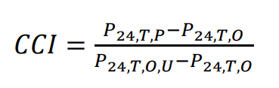

Where:

CCI = Climate Change Indicator

P*24,T,P*= Projected T-year 24-hour precipitation

P*24,T,O* = Observed T-year 24-hour precipitation

P*24,T,O,U* = Upper 90% confidence limit T-year 24-hour precipitation for the observed data

The Projected T-year 24-hour precipitation (P*24,T,P*) is determined by multiplying the Observed T-year 24-hour precipitation (P*24,T,O*) by the ratio of the future to baseline 24-hour precipitation quantile (R*q*). R*q* is determined by using *the FHWA Coupled Model Intercomparison Project (CMIP) Climate processing Tool*. The Observed T-year 24-hour precipitation (P*24,T,O*) and the Upper 90% confidence limit T-year 24-hour precipitation for the observed data (P*24,T,O,U*) are obtained from *NOAA Atlas 14 Point Precipitation Frequency Estimate: MA*.

FHWA reference HEC-17 describes a broad guideline, as follows,

* If CCI < 0.4, trend is weak, historical is OK.
* If CCI > 0.8, trend is strong, consider further analysis with future projections.

For CCI values that are between 0.4 and 0.8 should be weighed by the design team. To select the proper level of analysis for the subject project use the flow chart below.

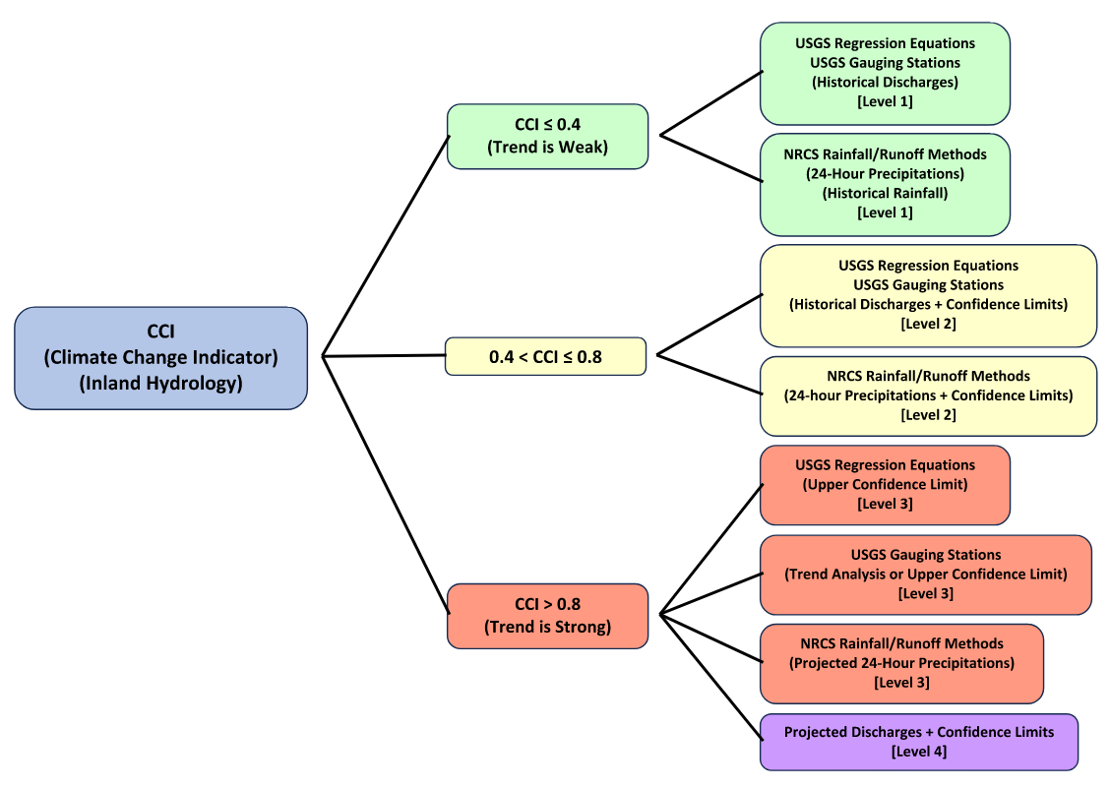

Figure 2.6.2-1: Climate Change Indicator – Level of Analysis

If the CCI value at the project’s site shows a strong trend, then the Hydraulic Design Data should include the Current Hydrology Conditions and the Projected Hydrology Conditions. The Projected Hydrology Conditions variables, e.g., the peak flows, the flood elevations, and velocities should be considered in the Scour Design and Scour Check calculations.

1. To the extent practicable, proposed bridges shall not cause any significant change in the affected waterway’s existing flooding regime over the range of discharges considered.
2. Proposed bridges crossing waterways which have established National Flood Insurance Program (NFIP) Special Flood Hazard Area (SFHA) Zone delineations, shall conform to applicable NFIP SFHA development performance standards as listed in *Title 44 Code of Federal Regulations, Section 60, Part 3 [44 CFR 60 (3)]* (Reference 41). In particular, proposed bridges crossing waterways with existing NFIP regulatory floodway delineations should not cause any increase in waterway’s base flood elevation (BFE) profile – or result in any unapproved increases to the width of the waterway’s effective delineation- anywhere in the affected community. If a proposed bridge, when constructed, will not meet applicable NFIP SHFA development performance standards, the Designer shall file a Conditional Letter of Map Revision (CLOMR) and, if warranted, a Letter of Map Revision (LOMR) with the Federal Emergency Management Agency (FEMA) as specified in *44 CFR 60 (3)* (Reference 5 and 41).
3. The “No-Rise” Floodway Encroachment Review procedure outlined in Subsection 2.6.6 shall be used to determine the degree to which proposed bridges crossing Regulatory Floodways meet applicable NFIP base floodplain development performance standards.