# CHAPTER 1 - INTERIM REVISIONS

#### 1.3.1.2 Stream Bed Sediment Particle Size Analysis. The following are guidelines for locations of soil samples and tests to be conducted for scour evaluations. Also included, when required, are the tests necessary to design granular and geotextile filter designs for scour countermeasures. These guidelines are the minimum requirements. Please note that, if the project's site exhibits signs of aggradation or degradation, a sediment transport analysis may be required, and additional soil samples may be needed. Please consult the MassDOT Hydraulic Engineer to determine if these guidelines are sufficient or if more soil samples are required.

The location of the samples to be collected for a given type of structure, in both Riverine and Tidal locations, are as indicated in Figures 1.3.1-1 through 1.3.1-4. The location of all samples shall be determined by the project’s hydraulic engineer and approved by the MassDOT Hydraulic Engineer.

For all stream crossings regardless of the stream bed material determine the bed material size characteristics based upon Table 1.3.1-1 below. The following test should be used based on the channel bed grain range size (S):

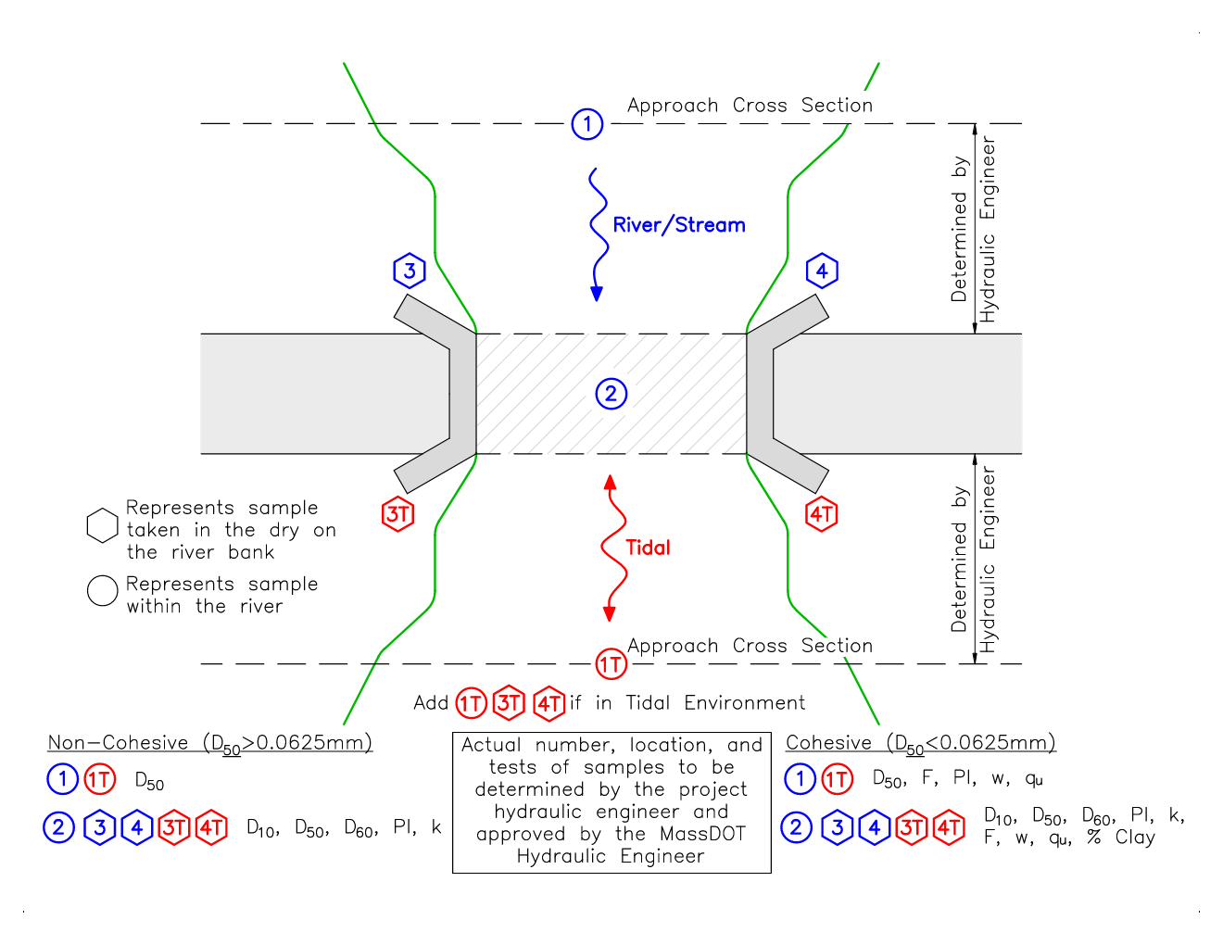

Figure 1.3.1-1: Single Span Bridge & Open Bottom Culvert in Riverine and Tidal Environment

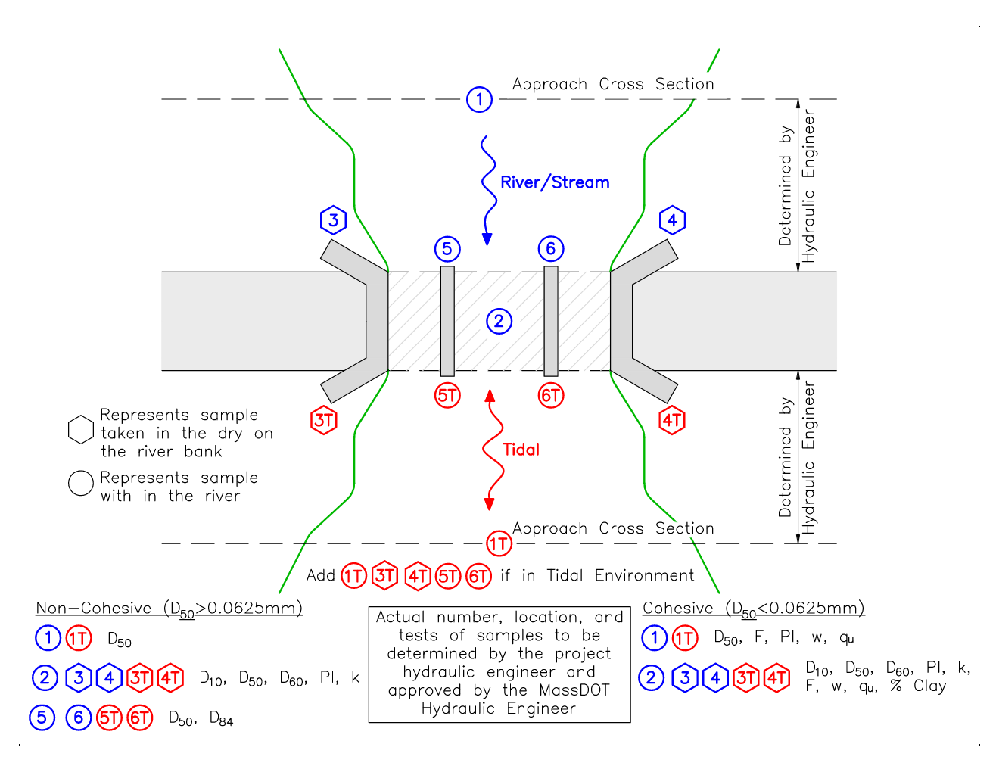

Figure 1.3.1-2: Multi Span Bridge in Riverine and Tidal Environment

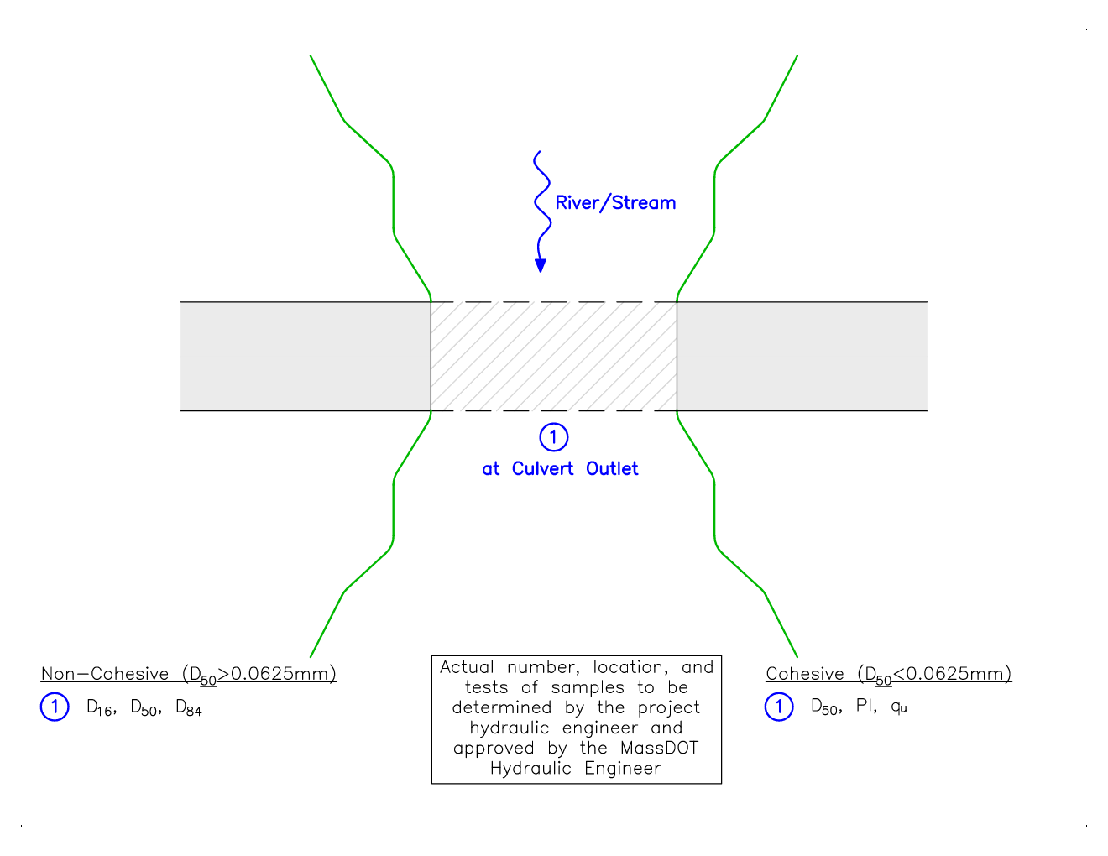

Figure 1.3.1-3: Closed-Bottom Single Culvert in Riverine Environment

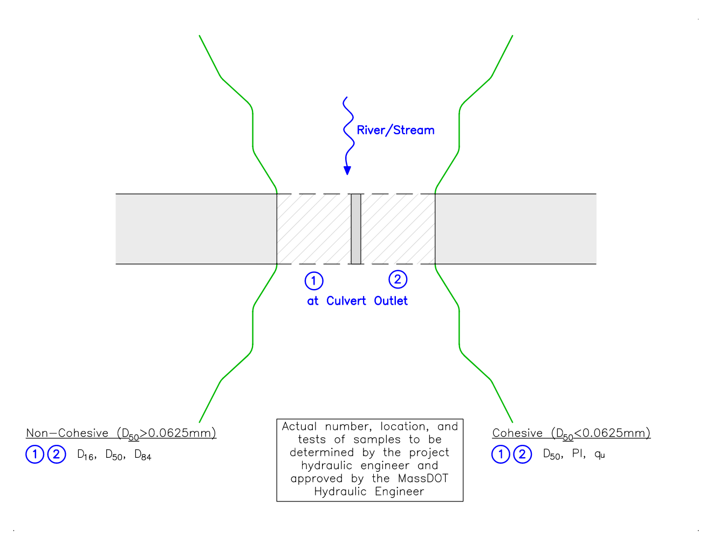

Figure 1.3.3-4: Closed-Bottom Multi Barrel Culverts in Riverine Environment